LINUX LAB

Name : M.Ramya sai Reg No : 17mis1148
Faculty : Prof Rukmani P Date : 5/6/2020

Simple Scripts to try

Script 1 :
apt-get install sl
sl

install the above command and check the output in terminal.

Explanation :

sl is just a fun command when you install the package and execute sl in terminal a train like structure will move in your terminal.

Output :

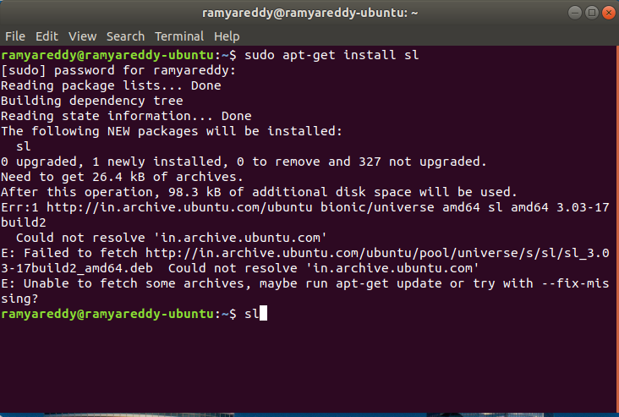

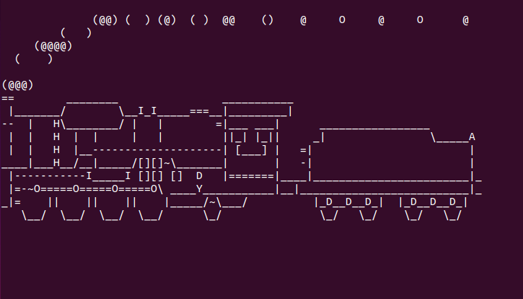

Script 2

rev
factor
yes

Explanation :
the command “rev” is used to reverse the lines. Once it is executed it will prompt for you to enter any word and when you press enter the word will be reversed and displayed.

Code :

Health.sh

vmstat 1200>vmstat1.data
filename="/home/ramyareddy/vmstat1.data"
tail -f $filename ׀
while read $line do
if [ (cat vmstat1.data ׀ grep "swap")>0 ]
then
echo "some rogue process has consumed massive amounts of memory">swap.txt
fi
if [ (cat vmstat1.data ׀ grep "r")>1 ]
then
echo "some process are waiting to execute">runqueue.txt
fi
if [ (cat vmstat1.data ׀ f=grep "cpu")>1000 ]
then
echo "cpu usage is more">cpu.txt
fi
End

Output :

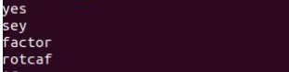

Hot question

Write a bash shell to monitor the health of four sysetm.Let the details be stored and archived in any folder of your choice

Health.sh

vmstat 1200>vmstat1.data
filename="/home/ramyareddy/vmstat1.data"
tail -f $filename ׀
while read $line do
if [ (cat vmstat1.data ׀ grep "swap")>0 ]
then
echo "some rogue process has consumed massive amounts of memory">swap.txt
fi
if [ (cat vmstat1.data ׀ grep "r")>1 ]
then
echo "some process are waiting to execute">runqueue.txt
fi
if [ (cat vmstat1.data ׀ f=grep "cpu")>1000 ]
then
echo "cpu usage is more">cpu.txt
fi
End

Explanation :

the vmstat 1200 – monitors every 24 hours and puts the data into the vmstat1.data

grep “swap”- the swap should always be zero if its not then some process has consumed massive memory. That will be monitored in this line

grep “r”- the running queue is constantly above process 1 it indicates the system is slow and some process is waiting to be executed. That will be monitored here.

Grep “cpu”- it indicates the cpu usage of the system. If the cpu usage is more it will be monitored and will alert in this line.

